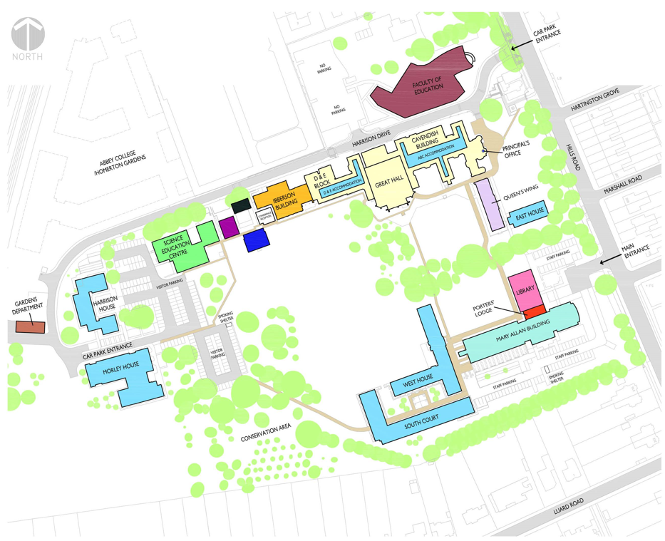

**ABBEY COLLEGE ASSEMBLY POINT**

**M**

**J**

**H**

**A**

**C**

**E**

**D**

**Purbeck**

**Rd**

New Dining Hall

Fellows Guest Rm

Conference centre

Principle’s Parking/Gate